The Fixed Link across the Fehmarnbelt
The Fehmarnbelt Fixed Link between Germany and Denmark is a project of international dimensions. The future tunnel link, which will open in 2021, is currently the largest transport project in northern Europe and one of the largest infrastructure projects in the world.
The expansion and improvement of the transport infrastructure will provide many new opportunities for nine million people and thousands of companies across the Fehmarnbelt region, i.e. in northern Germany, Denmark and Scania in Sweden.
Economically, culturally and socially, new relationships will emerge and new opportunities created for trade, tourism and jobs as well as for living and working in the area.
The project is high on the EU’s list of essential traffic corridors. The objective is to strengthen the capacity for rail freight. The EU supports the Fehmarnbelt project financially.
Timetable
Femern A/S is tasked with establishing a fixed link between Rødbyhavn and Puttgarden. The link will comprise a dual-track railway and a four-lane motorway. In September 2008, Denmark and Germany signed a state treaty for the project. In 2011, the Danish Parliament announced that an immersed tunnel is the preferred solution. The tunnel construction now has to be approved in both countries – in Denmark by means of a Construction Act, and in Germany by a plan approval decision.
In May 2013, Femern A/S prequalified nine international consortia. They have been invited to tender for one or more of the four major tunnel construction contracts. The tendering process was officially launched at the start of September 2013. In addition, the public consultation on the project’s Environmental Impact Assessment (EIA) was held in Denmark between the end of June and the end of September 2013. In Germany, the plan approval documents were submitted to the German plan approval authority in October 2013. Until the planned start of construction in 2015, Femern A/S will focus on the following tasks
- Negotiations with the prequalified contractors
- Management of the Danish approval procedure until the Construction Act is brought before the Danish Parliament
- Management of the German plan approval procedure until the plan approval decision is issued
- Conduct of advance construction works on Lolland
- Continuing dialogue about the project with the authorities, local residents and other stakeholders in Denmark and Germany.

At the end of 2014, Femern A/S will receive estimates from the contractors and proposals will be put forward for a Construction Act.

In 2015, it is expected that the Danish parliament will pass a Construction Act and that regulatory approval will be obtained in Germany. Femern A/S will subsequently sign contracts with the successful contractors. Construction can then get underway during the summer of 2015.

Financing
As the owner of the project, Denmark is responsible for the financing of the coast-coast link and for the Danish landworks while the German government will finance the project’s landworks in Germany.
The fixed link across the Fehmarnbelt will be financed by loans covered by Danish government guarantees, as well as by grants from the EU. The cost of construction for the coast-coast link is estimated at around EUR 5.5 billion (2008 prices).
The users pay
The charge for a passenger car driving through the tunnel is expected to be on a par with the Rødbyhavn–Puttgarden ferry crossing in 2007, adjusted for general price trends. In 2007, the cost of taking a car on the ferry was EUR 56.
The construction loans for the Fehmarnbelt link will be paid off by its users, as is the case with the Øresund and Great Belt Bridges. The cost of the fixed link across the Fehmarnbelt, including the Danish landworks, is expected to be repaid in approximately 39 years.
Traffic
There is already heavy traffic across the Fehmarnbelt. In 2012, the average daily traffic on the ferries between Rødby and Puttgarden was approximately 5,300 vehicles per day. This figure is expected to rise as the opening of the fixed link draws near.
When the link opens in 2021, an average of 8,000 vehicles, 78 freight trains and 40 passenger trains are expected to use the tunnel on a daily basis.
Immersed tunnel
The fixed link will be designed as a 17.6 km immersed tunnel for vehicles and trains because this is deemed to be the best solution overall in terms of traffic, safety and the environment.
At a speed of 110 km per hour on the motorway, motorists will have a journey time through the tunnel of approximately 10 minutes. For rail passengers, the journey will take approximately seven minutes.
Not only will the Fehmarnbelt tunnel be one of the most modern and the safest in the world, it will also be the world’s longest combined road and rail tunnel.
The design and building methods for an immersed tunnel are well established, but the large scale together with the depth of the belt – up to around 30 m – represent an engineering challenge.
The tunnel will be constructed from 79 standard elements, each 217 m long, and 10 shorter special elements, which will be placed at distances of approximately 1.8 km. The tunnel elements will be produced at a large production plant on land under controlled conditions. The elements will weigh 73,500 tonnes and can float. They will be towed to the tunnel alignment where, one by one, they will be lowered into a dredged trench and connected together. Once the elements are in place, they will be covered by stones and sand.
Production facilities at Rødbyhavn
The production facilities for the tunnel elements will be constructed in an area east of the ferry port at Rødbyhavn.
The production plant will provide work for several thousand people over the approximately six and a half year long construction period.
The entire construction will create employment corresponding to a total of 55,000 man-years. Of these, 25,000 man-years will be directly linked to the actual construction sites at the Fehmarnbelt, while a further 30,000 man-years will be created at the companies that are subcontractors to the construction sites. This means that for every employee with the major contractors on the construction project, there will also be one job created at the many companies that are subcontractors to the project. During the six and a half years of construction, approximately 4,000 direct jobs will be created at the construction sites and a similar number of indirect jobs on the suppliers’ side. Furthermore, there will be approximately 500 training positions for apprentices during the construction works. The creation of apprenticeship training positions is part of the contractual requirements for the future construction companies.
Although international consortia will head up the main construction works, local Danish and German labour are, to a large extent, expected to be involved in the project.
The construction time for the immersed tunnel is six and a half years.

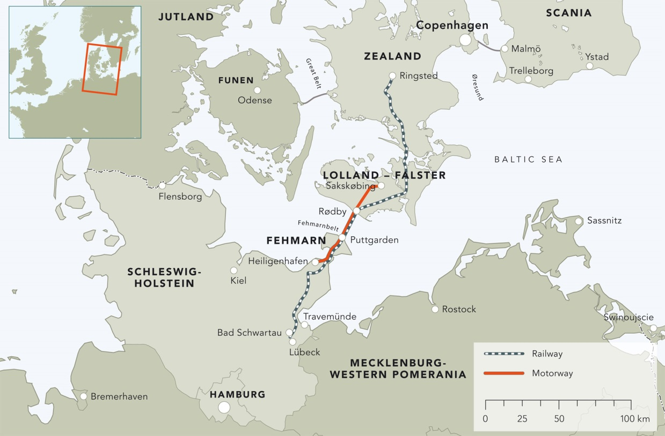
The Fehmarnbelt region (above) – the tunnel portal at Rødbyhavn (below)
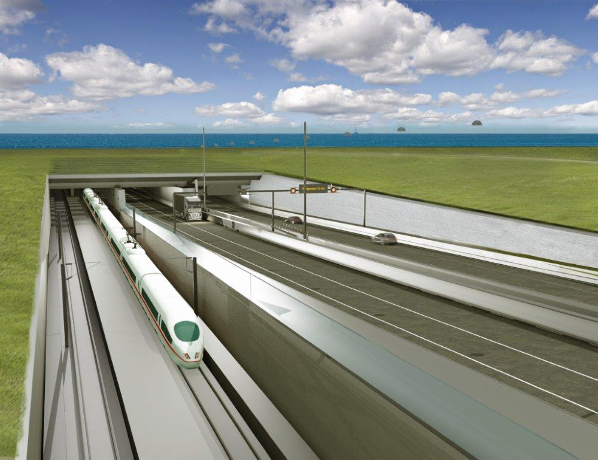
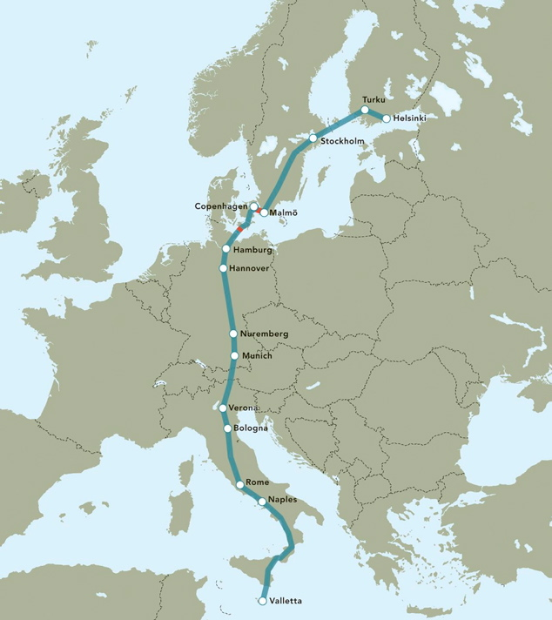
The EU transport corridor Helsinki-Valletta. The Fehmarnbelt Fixed Link and the fixed link across the Øresund are marked in red.
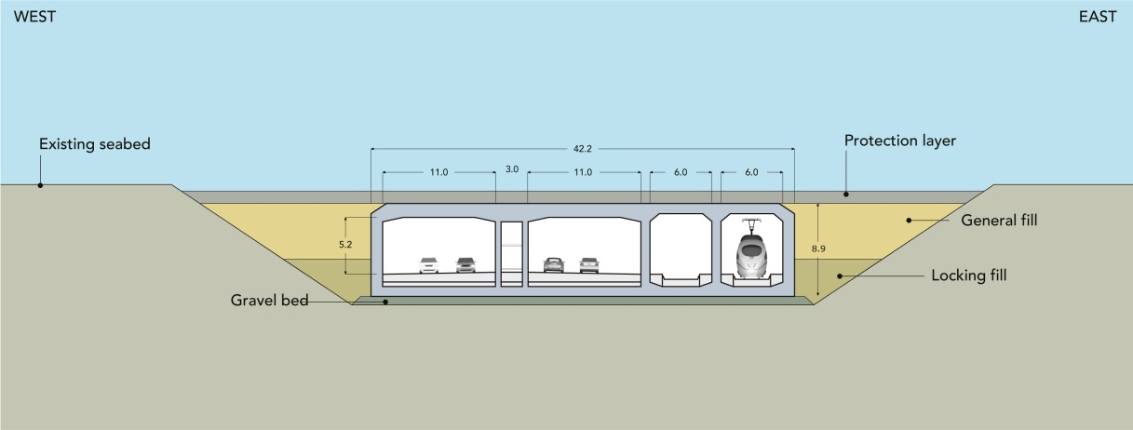
Standard element. The immersed tunnel will consist of 79 standard elements and 10 special elements.
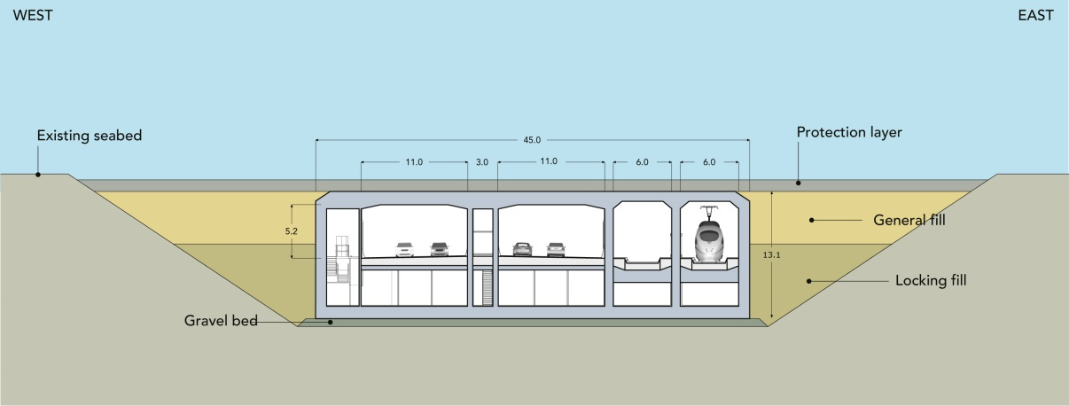
Special element. The special elements will ensure that ongoing operations and maintenance can take place with no disruption to traffic.
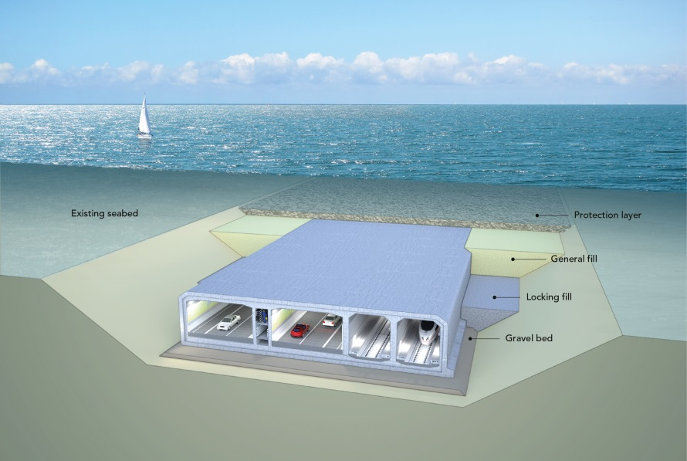
The tunnel is located on the seabed in a dredged trench. When the tunnel is completed, it will be covered with stones. Within a few years, the natural seabed will have been restored.

All documents, diagrams (at a print-quality resolution) and other background material can be found at http://www.femern.com/service-menu/press--documents. Broadcast-quality videos on the project are available at http://femern.dicentia.dk/.

