Facts about the project

Extensive geological and geotechnical investigations
Since 2008, Femern A/S has invested more than 50 million Euros (approximately DKK 375 million) in the Fehmarnbelt investigations. More than 2,500 samples have been taken from the bottom of the belt and coastal areas, and all parts of the areas where the tunnel is to be built will be investigated down to the smallest detail.
As a result, an exceptional information resource will be developed for contractors before they move in and begin construction of the 18 km long immersed tunnel between Rødbyhavn and Puttgarden.
Overall, the ground in the Fehmarnbelt is fairly complex, although it consists of well-known soil strata. The most common are basin sediments (clay, silt, sand), tills, Palaeogene clay and chalk. The chalk lies so deep that it will not have a significant impact on the construction of the tunnel.
All the findings are summarised in reports and analyses, which are available to the engineering consortia that will bid on contracts for the tunnel. The studies were conducted in four phases.
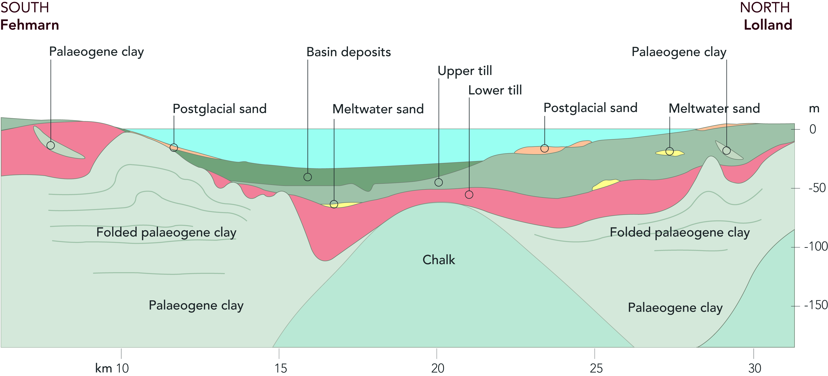Subsoil in the Fehmarnbelt seen in cross section.

- 1. Geophysical surveys

The first phase of charting the area began more than five years ago with geophysical surveys, i.e. measurements of physical conditions in the soil and seabed. The aim was to gain a thorough overall geological understanding of the subsoil.

As part of the survey, in 2008 and 2010 a vessel conducted a series of seismic surveys on a large area of the Fehmarnbelt close to the Rødbyhavn-Puttgarden ferry route. The measurements were made in survey lines with a spacing of only 25 metres.

In this phase, a project-specific positioning system was established. Four satellite relay stations have been set up that receive, adjust, and forward positioning signals from the US GPS, the Russian Glonass and, later on, the European Galileo system. It allows positioning in the area with an accuracy of a few millimetres. The system is to be used by all contractors.
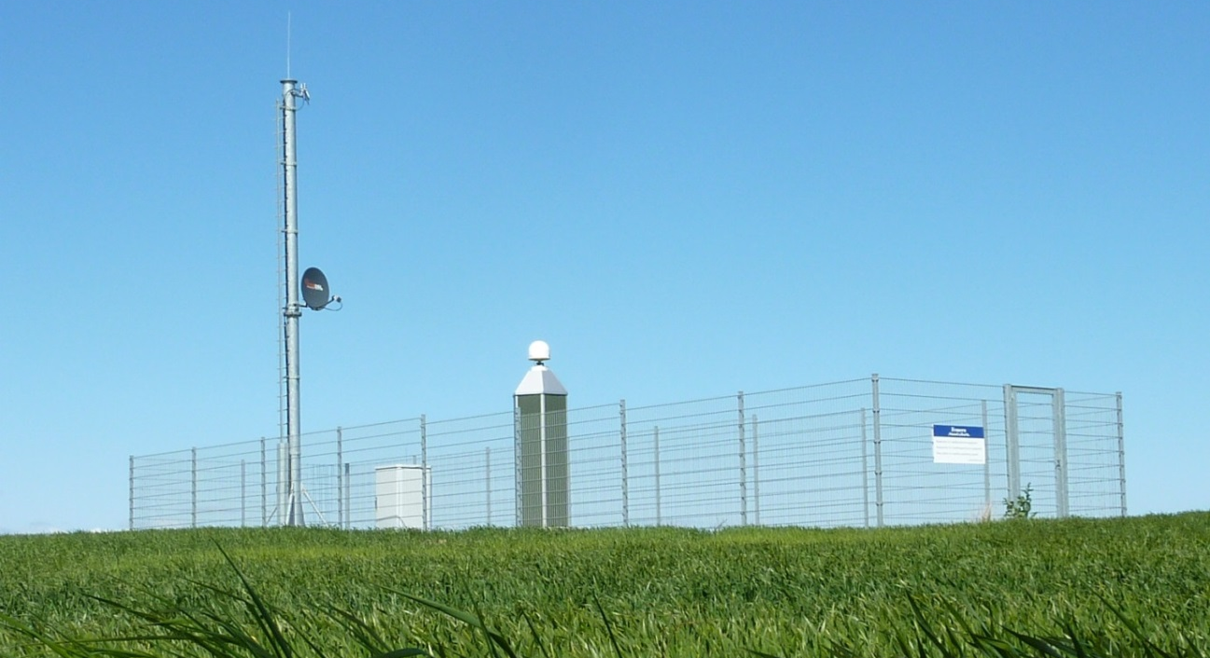
Four satellite stations allow positioning in the area with an accuracy of a few millimetres

2. Geotechnical borings
In 2009, Femern A/S began to carry out the first borings on land and at sea down to a depth of 50-100 m along a two km wide corridor, which covers the tunnel’s future alignment. The aim was to collect high quality soil samples, to map the soil layers, and to measure, among other things, soil strength. The borings confirmed the geological conditions.

Some of the soil layers in the Fehmarnbelt are similar to those found at the old Lillebælt bridge in Denmark and at the Fehmarnsund bridge in Germany. Settlement measurements have been carried out on an ongoing basis since the bridges opened to traffic in 1935 and 1963 respectively. Femern A/S, therefore, has conducted correlation borings at these two bridges.

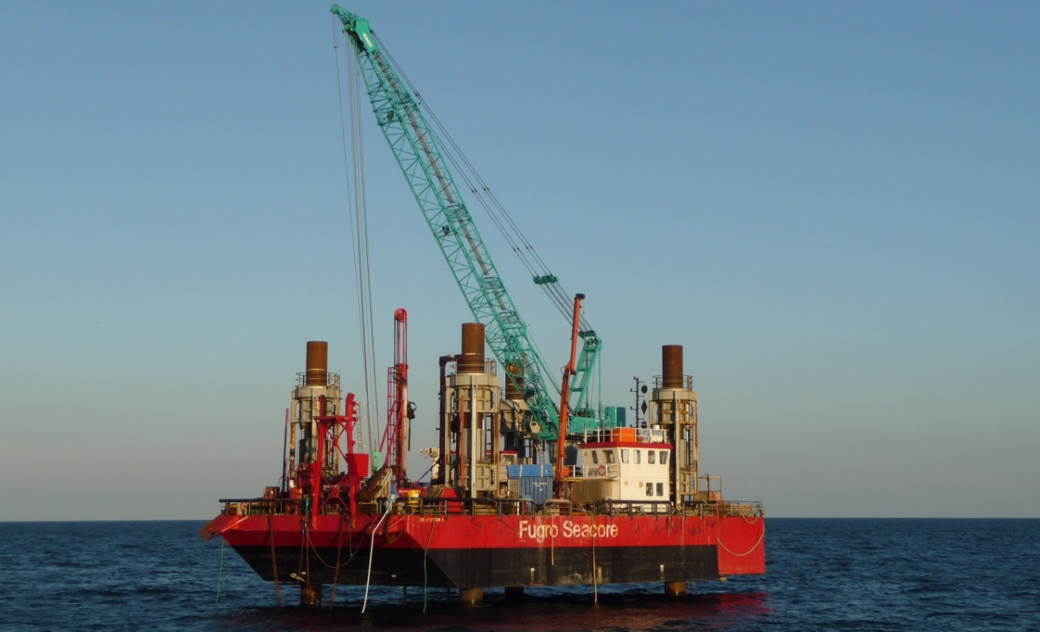
Borings on land and at sea reach depths of 50-100 m.

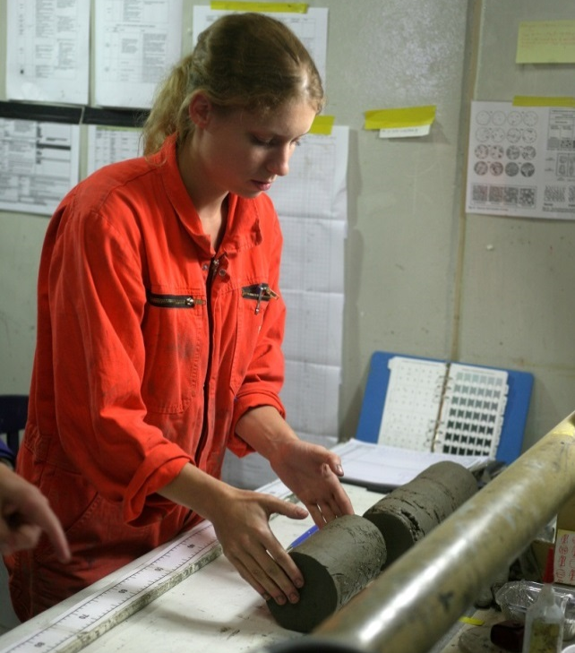
3. Laboratory tests
All the collected soil samples from the Fehmarnbelt have undergone laboratory testing and approximately 600 selected samples were sent to specialist laboratories where they were further analysed to determine soil deformation and strength properties.

As part of the advanced testing in the laboratories, soil samples were restored to the natural load levels that they were exposed to before being collected. They were then subjected to simulated impacts corresponding to those that would be expected from an immersed tunnel or a bridge.
About 600 samples from the subsoil have been tested in laboratories.

- Large-scale tests
It became clear that the so-called Palaeogene clay layer, which is highest near the coastal areas, should be subject to a specific in-depth study because of doubts over the nature of the clay and how it would react when subjected to different loadings.

Femern A/S therefore set up a special test field approximately one km off the German coast at Puttgarden and implemented a multi-annual series of large-scale experiments in which soil movements were measured under various load conditions. The studies focused on illustrating how load-bearing structural components would interact with the subsoil. The results have provided important insights into how the subsoil heaves and settles and what load bearing capacity can be expected during the foundation of piles and ground anchors.

The studies have shown that the challenges posed by dredging and then building the tunnel can be met.

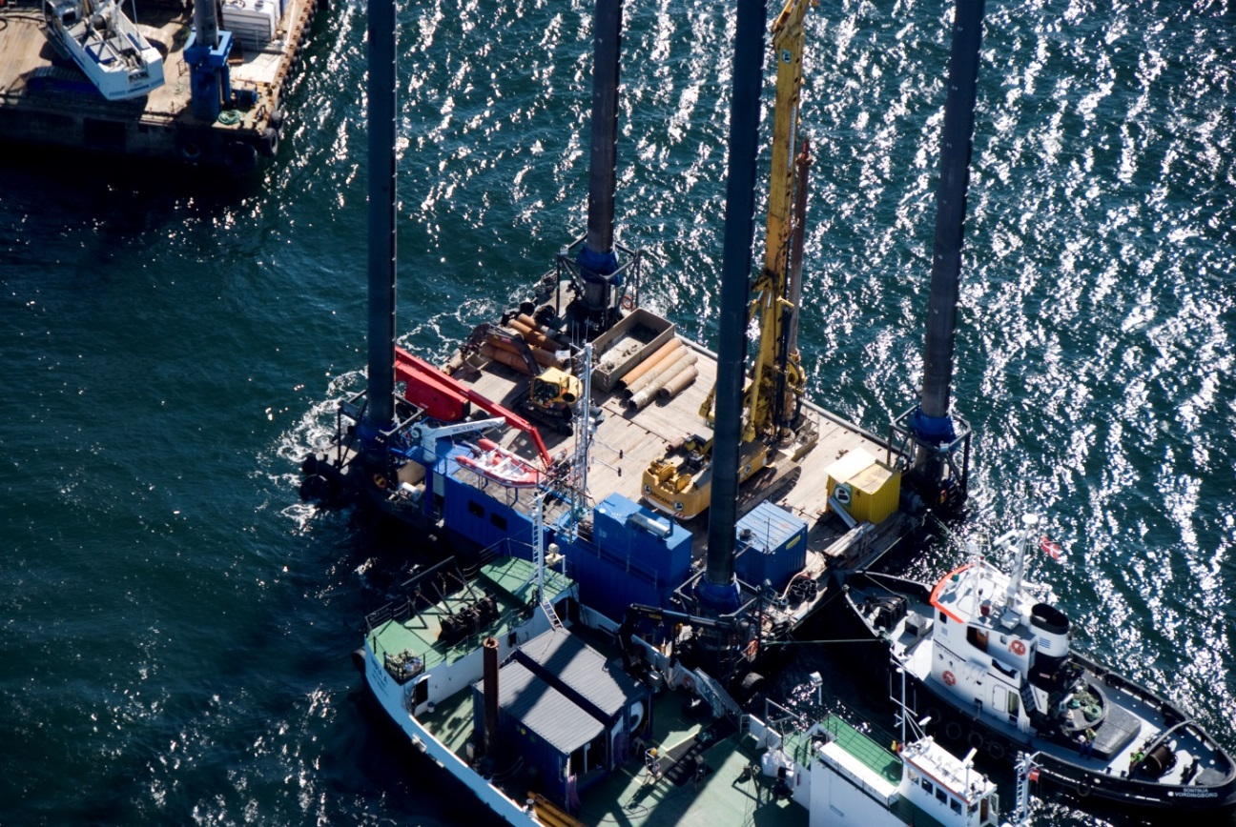
A special test field off the coast of Fehmarn has enabled detailed studies of the Palaeogene clay layer.

